It is important to understand that as a healthcare practitioner, and therefore a clinician, that the founding principles behind health practice is well understood.
As a healthcare practitioner, the goals of service to the patient are:
- Address the presenting chief complaint (PCC) of the patient
- Screen the the patient's health:
- Medical information
- Dental information
- Social information (where relevant)
- physical anatomy
- Evaluate the health and provide a diagnosis and overall impression of the patient
- Evaluate a suitable treatment plan suited to the diagnosis and impression
- Provide treatment as consented and necessary
- Review the patient for ongoing health maintainence and confirm success of treatment
Therefore, the first principle skill to build in order to develop a foundation befitting of a healthcare practitioner is the ability to identify what is normal and what is not normal
Defining anatomical terms
Direction
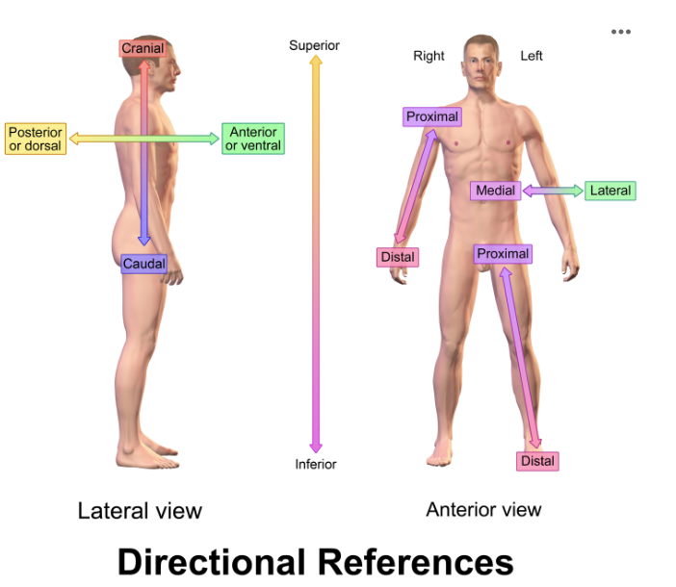

The anterior direction is front facing, posterior direction is back facing.
Medial direction is towards the midline, lateral direction to away from midline.
Superior direction is upwards, inferior direction is downwards. Do not confuse this with cranial direction and caudal direction, which are towards the brain and away from brain, respectively.
When assessing peripheral attachments (such as arms or legs, or bones) proximal direction is towards the proximity (therefore centre of body), and distal direction is award from proximity.

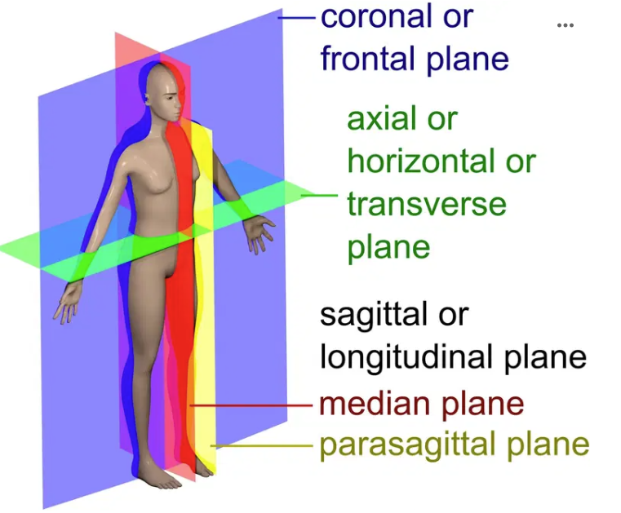

Anatomical planes can also be considered in description of anatomy, in which the view from the anterior of the patient is described as the coronal/frontal plane. The view from the lateral of the patient is described as the sagittal/longitudinal plane. The view from the vertical cross-section of the patient is described as the axial/horizontal/transverse plane.
Tissue refers to a specific group of cells in the body that provides structure and function. Hard tissue refers to the componentry of the body that is calcified, and therefore, "hard". Soft tissue therefore refer to componentry of the body that attaches to the hard tissue and key organs and provides elastic support. The assessment of soft tissue in the key beginning of patient assessment (when assessing the anatomy).
Within Dentistry, the core components of soft and hard tissue that are assessed are:
Extra-oral (extra = outside/peripheral, oral = mouth)
- General facial symmetry
- Muscles of mastication (masseter, temporalis, lateral pterygoid, medial pterygoid)
- Temporo-mandibular joint
- lymph nodes
Intra-oral (intra = within)
- Labial/buccal mucosa
- Palate (hard and soft palate)
- Tongue
- Floor of the mouth
- Gingiva (gums)
- Dentition (teeth)
Muscles of mastication
The muscles of mastication are key muscles within the facial structure that control the temporo-mandibular joint (TMJ). That is to say, there are various muscles that exist in the facial structure, most (but not all) of which control facial expressions, but muscles of mastication are explicitly to do with the TMJ control.
Note that the description of the muscles is a simplified view, and there exists far more complex nuances to the connections and functions of the muscles.
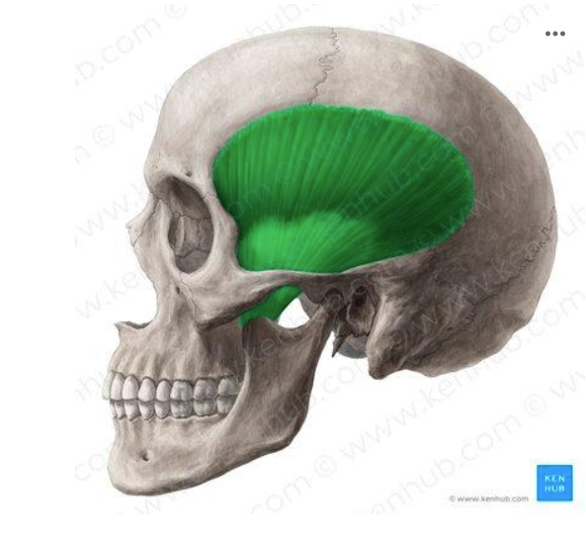

The temporalis muscle is the largest muscle of the face, and connects the TMJ to the temporal bone of the head. This allows for vertical movement of the TMJ.

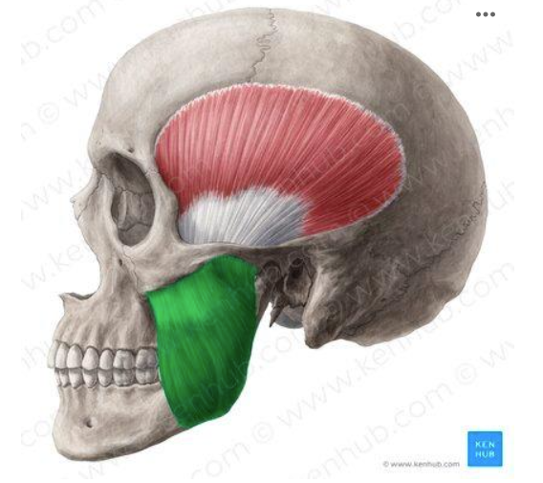
The masseter is the muscle that connects the lower border of the lower jaw (mandible) to the zygomatic arch (cheek bone). This also allows for vertical movement of the TMJ.

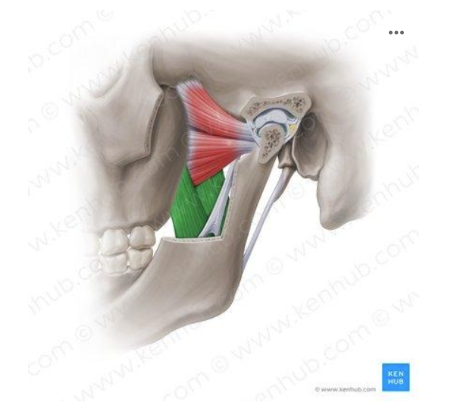

The lateral pterygoid muscle (the pink coloured muscle) is the muscle that connects both the mandible and the TMJ to the posterior border of the upper jaw (maxilla). This allows for anterior (forward) movement of the TMJ and lateral movements.

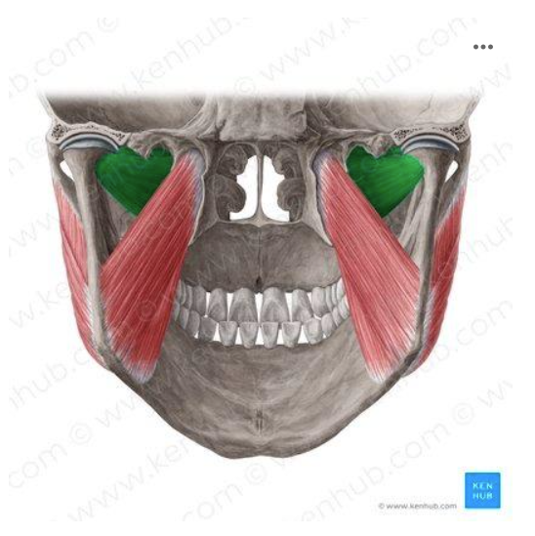

The medial pterygoid muscle is the final muscle of mastication which connects the medial surface of the lower border of the mandible to the maxillary and palatine bones. This muscle also allows for anterior movement of the mandible.
Note that as per the names, the lateral pterygoid muscle connects to the external surface of the mandible (hence lateral), and the medial pterygoid muscle connects to the internal surface (hence medial).
Temporo-mandibular joint (TMJ)

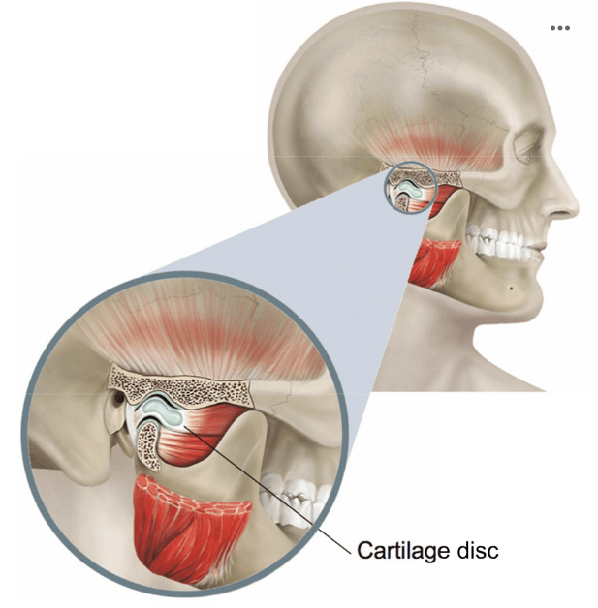
The joint is an entity that communicates between 2 bones and a cartilaginous tissue that facilitates the motion between the 2 bones. Hence, the shoulder, elbow, hips, and knees all are common examples that demonstrate the existence of a joint.
The temporo-mandibular joint is unique in this instance as it is the only joint in the body where the joint of the left and right are both conjoined, and hence cannot function separately. Simply put, your arms and legs can individually move, however your jaw must move its left and right together, but not necessarily in unision. It does not have to be in unison as moving your jaw forwards or opening your jaw means both joints move in the same direction, but if you grind your jaw to one side, each joint moves in opposing directions.
Remember that the lateral pterygoid muscle is the only muscle of mastication that joins directly to the cartilage disc.
The lymphatic system is an unique network that communicates between various organs and tissues through the movement of lymph fluid. The lymphatic system is part of the immune system that works as a defensive mechanism against noxious stimuli that invades the body. Colloquial put, the lymphatic system is commonly describes as a defence network that "drains" infection. Note that this description is not accurate, however provides a well-designed idea of its essential function.
The lymph nodes, therefore, are specific entities of nodes that can collect lymph fluid. These nodes provide specific anatomical location where the immune cells can congregate for additional functions.

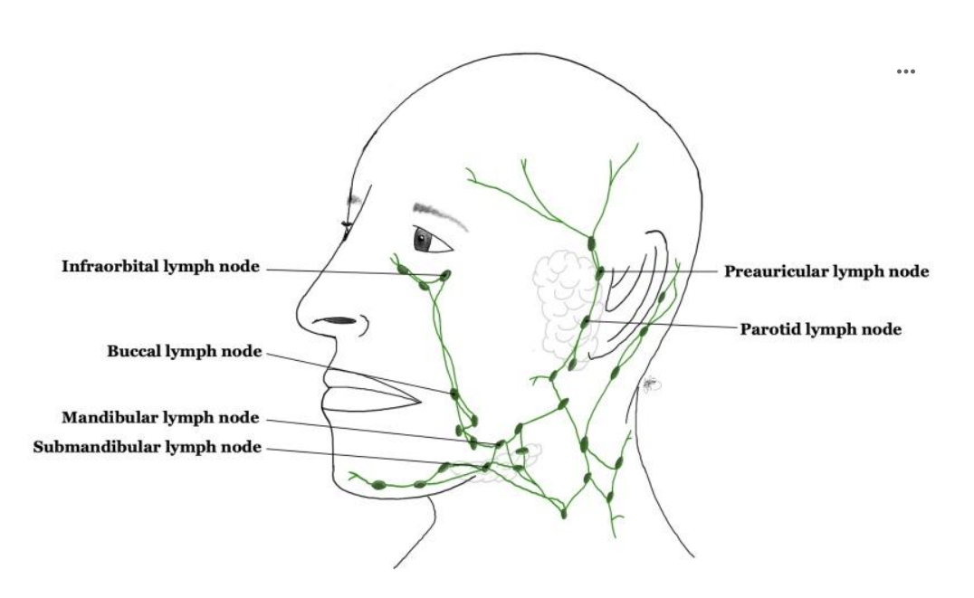

Note that in the facial structure, various passageways exist for the lymph node networks, of which, another entity (which is not named in the image) that is commonly assessed in Dentistry is the occipital lymph node.
Infection vs inflammation
- Inflammation describes the immune response of the host to any noxious stimuli (thermal, chemical, mechanical, trauma, etc) in order to a homeostatic balance
- Infection, on the other hand, describes the process and activity of micro-organisms and the host response to its invasion
Hence, inflammation describes the activity where the host body attempts to achieve resolution, whereby an infection can be one subset of possible causes.

